# Image result for south metropolitan tafe logo

PROGRESS REPORT

*2017*

BY-SANDEEP SINGH

STUDENT ID – M228854

**VIEW OF WORK DONE**

Report shows contribution in CAD drawings and CAD documents. Also contains data collected on sensors used in CNC lathe. Report includes every detail of sensor like price, function and characteristics. It also have got attached internet links to reach specific website for every sensor. Report completed with help of internal and external references ex. (Michael Blackburn) (A160) and lecturer Daniel. Report finished by taking Australian Standards into consideration.

DATA TABLE FOR SENSORS

|  |  |  |  |
| --- | --- | --- | --- |
| Ser.no | Number of sensors | Sensor researched | Total price |
| 1 | 1 | Slide door sensor | 278.76 |
| 2 | 4 | Limit switch | 93.84 |
| 3 | 1 | Float switch | 17.54 |
| 4 | 2 | Inductive sensor | 36.53 |

3 jaw, 4 jaw chuck drawings and chuck

3 jaw chuck

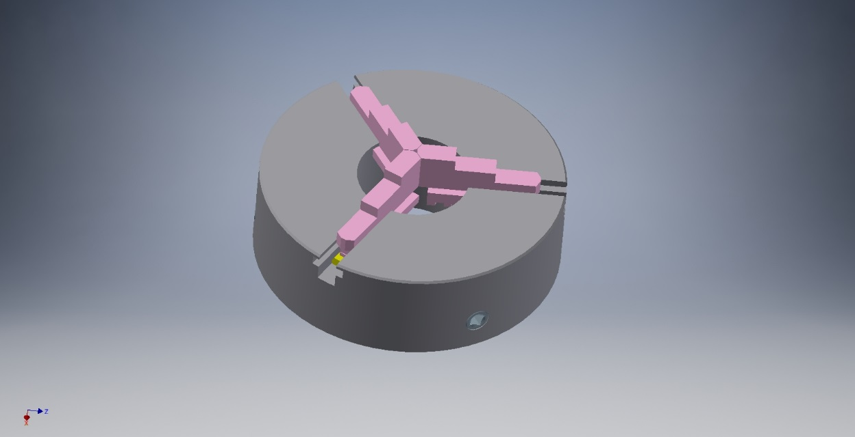

4 jaw chuck

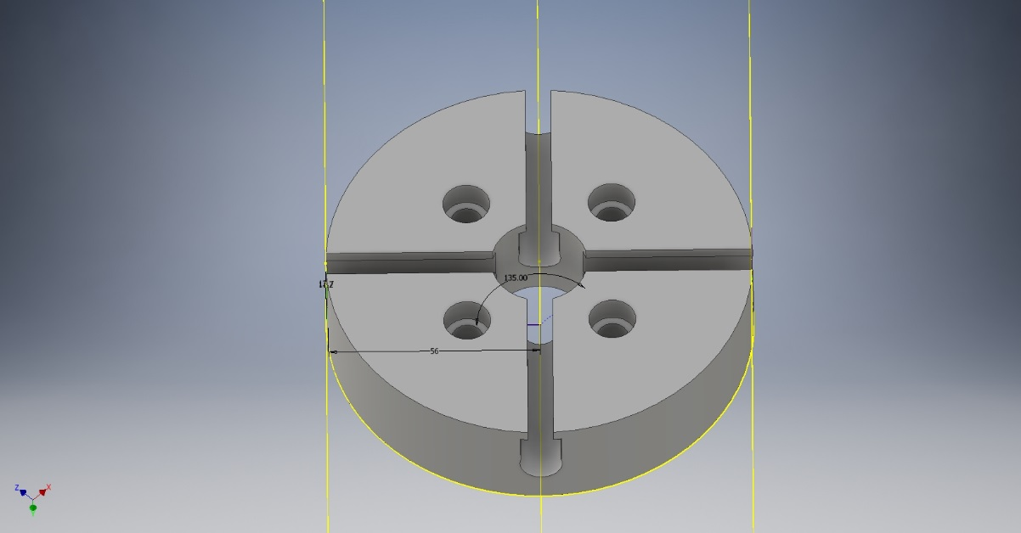 Chuck hold

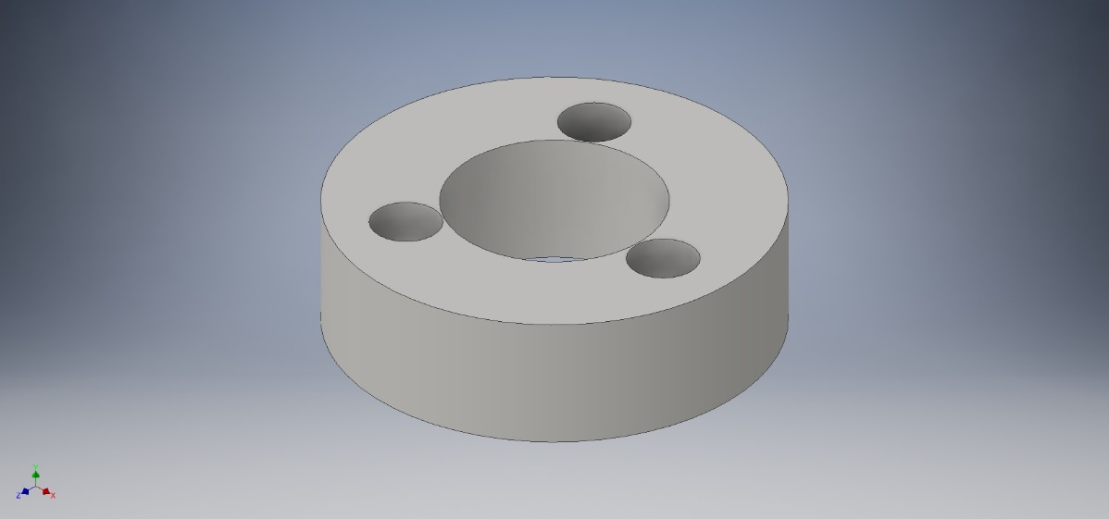

Researched data:

# SLIDING DOOR SENSOR

Motion detectors, or optical sensors, are the most common types of sensors used on automatic doors. These sensors detect movement and are installed on the sides of the doors. Once movement is detected, the doors open. Another common type of sensors used for automatic doors are pressure sensors. These sensors are placed in a large area in front of the door and they sense pressure, which causes the doors to open. Door sensors work because they use a sensor and a magnet. The sensor is placed on the door frame and the magnet on the door itself. A circuit attached to the magnet sends a message to the alarm when the current is disturbed when the door is opened.

Reference <http://www.autonics.com/products/products_detail.php?catecode=01/04/01&db_uid=64>

We need the ADS-AE type for sliding door sensor.

NUMBER NEEDED- 1

TOTALPRICE - $278.76

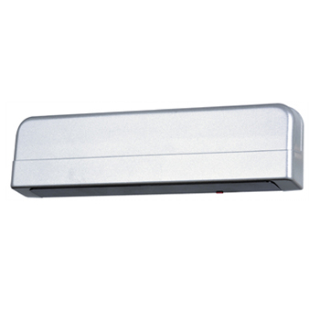

# LIMIT SWITCHES

In [electrical engineering](https://en.wikipedia.org/wiki/Electrical_engineering) a limit switch is a [switch](https://en.wikipedia.org/wiki/Switch) operated by the motion of a machine part or presence of an object.

They are used for controlling machinery as part of a [control system](https://en.wikipedia.org/wiki/Control_system), as a safety interlocks, or to count objects passing a point. Limit switch is an electromechanical device that consists of an actuator mechanically linked to a set of contacts. When an object comes into contact with the actuator, the device operates the contacts to make or break an electrical connection.

Visible operation  
Able to switch strong currents – 10 A conventional thermal current  
Electrically separated contacts  
Precise operating points – consistency  
Variety of operating heads, plain plunger, roller plunger, Roller lever  
Double insulation

NUMBER NEEDED- 4

TOTAL PRICE – 4 X 23.46 = $93.84

Reference:

## <http://au.rs-online.com/web/p/limit-switches/9026871/>

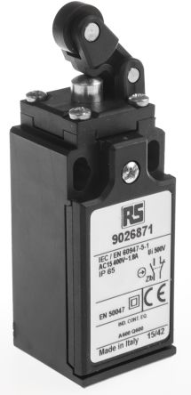

# FLOAT SWITCH

How Float Switches Work

The purpose of a float switch is to open or close a circuit as the level of a liquid rises or falls.  Most float switches are “normally closed,” meaning the two wires coming from the top of the switch complete a circuit when the float is at its low point, resting on its bottom clip (for example, when a tank is dry).

NUMBER NEEDED-1

TOTAL PRICE -$17.54

Reference

"<http://au.rs-online.com/web/p/level-sensors-switches/8697595/>"

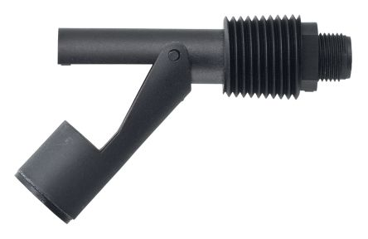

# INDUCTIVE SENSOR

<http://au.rs-online.com/web/p/inductive-proximity-sensors/8054711/?sra=pstk>

We are choosing this sensor http://au.rs-online.com/web/p/inductive-proximity-sensors/8052602/

WE are using 2 sensors for homeing costs -$36.53 each

